Cloud Computing (Lab 12)
Name : Tooba Shafique
Reg no : 2023-BSE-065
BSE-V-B
Lab 12 — Terraform Provisioners, Modules & Nginx Reverse Proxy/Load Balancer
Objective
- Use GH CLI inside a Codespace
- Organize Terraform code into separate files
- Practice Terraform provisioners (user_data, remote-exec, file, local-exec)
- Create reusable Terraform modules for subnet and webserver
- Configure Nginx as reverse proxy and load balancer
- Implement SSL/TLS with self-signed certificates
- Configure Nginx caching
- Implement high availability with backup servers

Task 0 — Lab Setup (Codespace & GH CLI)
Screenshots Required:
- task0_codespace_create_and_list.png
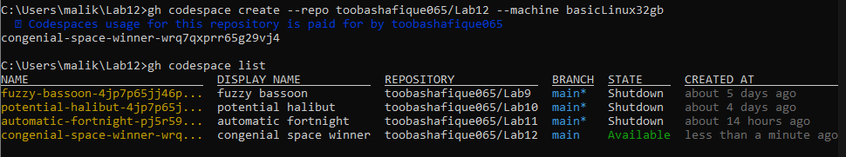
- task0_codespace_ssh_connected.png
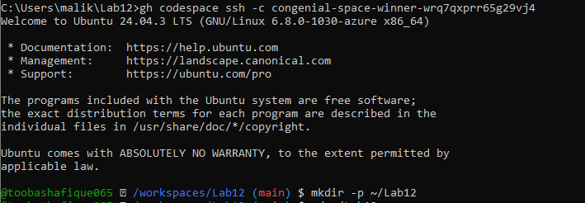

Task 1 — Organize Terraform Code
Screenshots Required:
- task1_project_directory.png
- task1_files_created.png
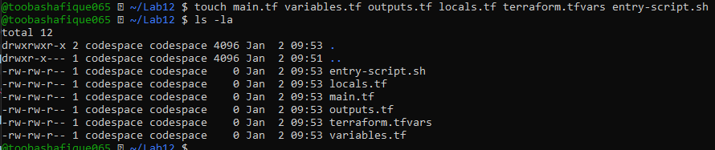
- task1_variables_tf.png
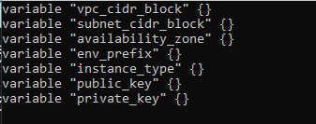
- task1_outputs_tf.png
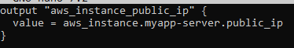
- task1_locals_tf.png
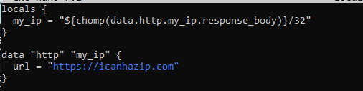
- task1_terraform_tfvars.png
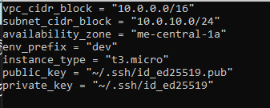
- task1_main_tf.png
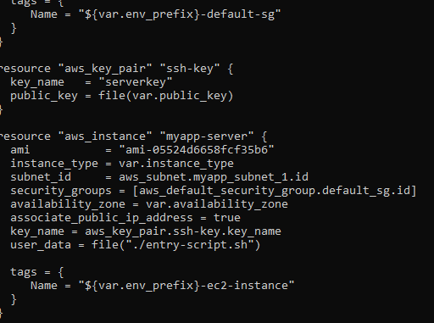
- task1_entry_script.png
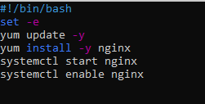
- task1_ssh_keygen.png
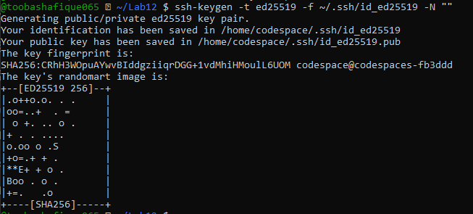
- task1_terraform_init.png
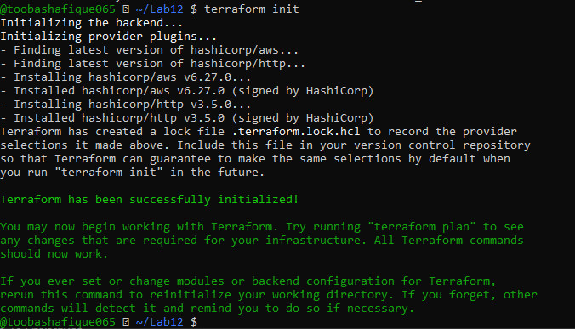
- task1_terraform_apply.png
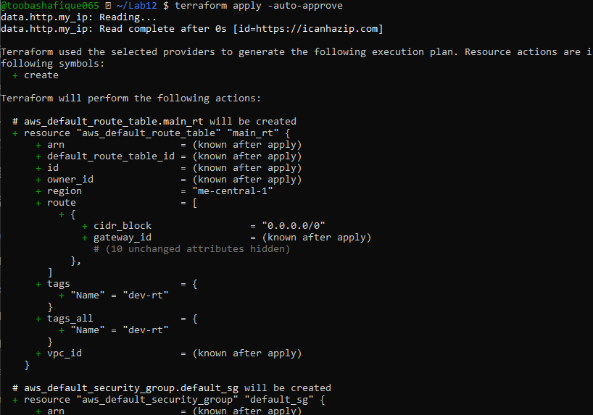
- task1_terraform_output.png
- task1_nginx_browser.png
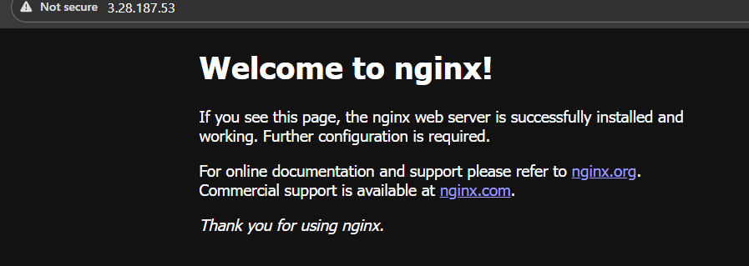
- task1_terraform_destroy.png
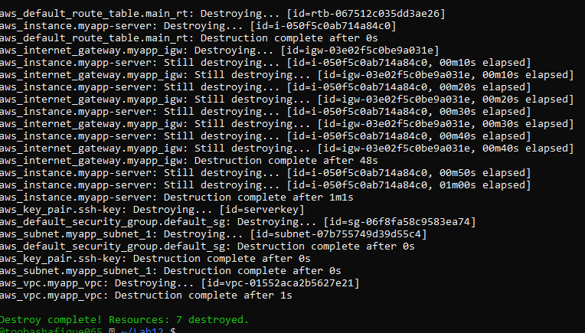

Task 2 — Remote-exec Provisioner
Screenshots Required:
- task2_main_tf_remote_exec.png
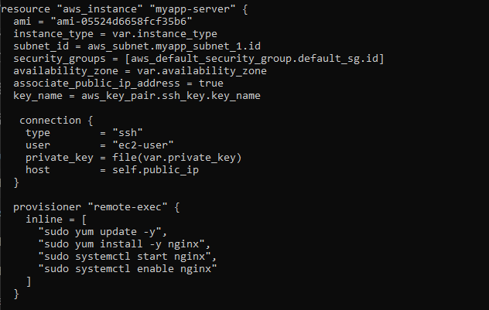
- task2_terraform_apply.png
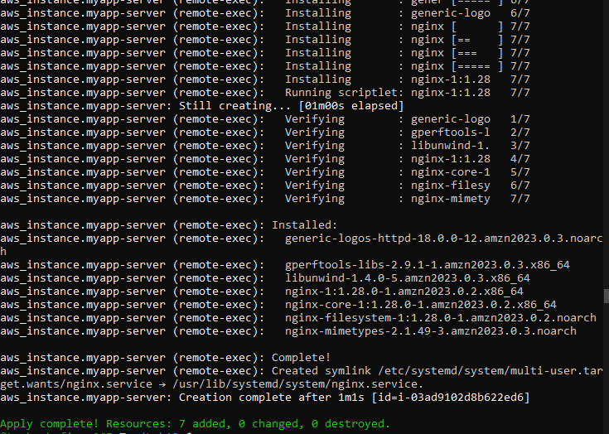
- task2_terraform_output.png
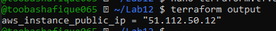
- task2_nginx_browser.png
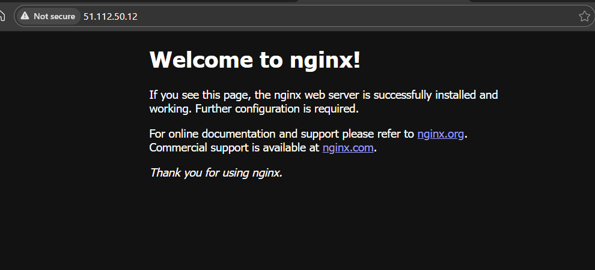

Task 3 — File & Local-exec Provisioners
Screenshots Required:
- task3_main_tf_all_provisioners.png
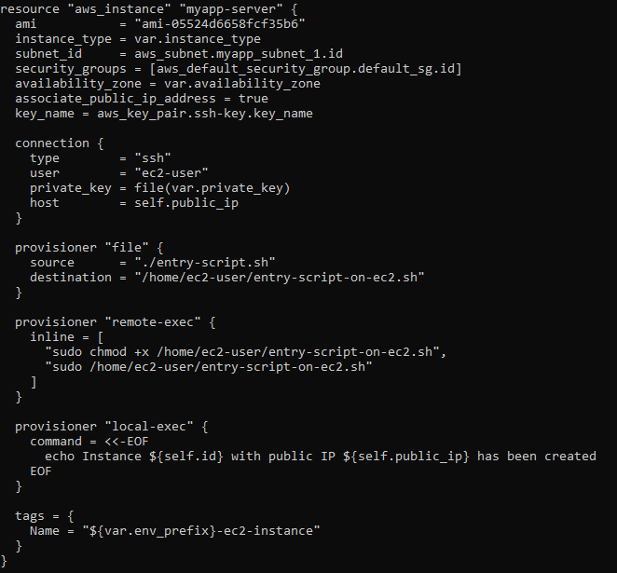
- task3_terraform_apply.png
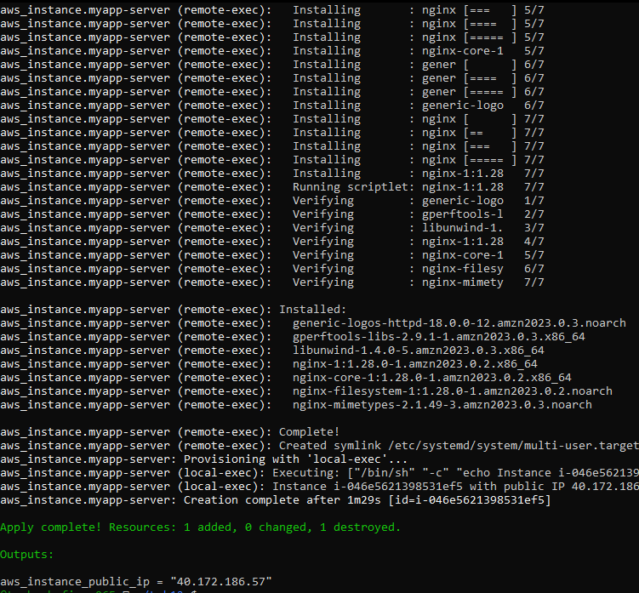
- task3_terraform_output.png
- task3_nginx_browser.png
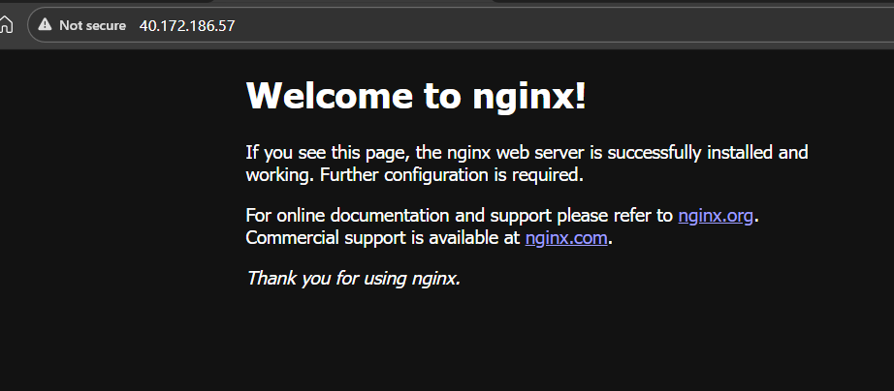
- task3_terraform_destroy.png
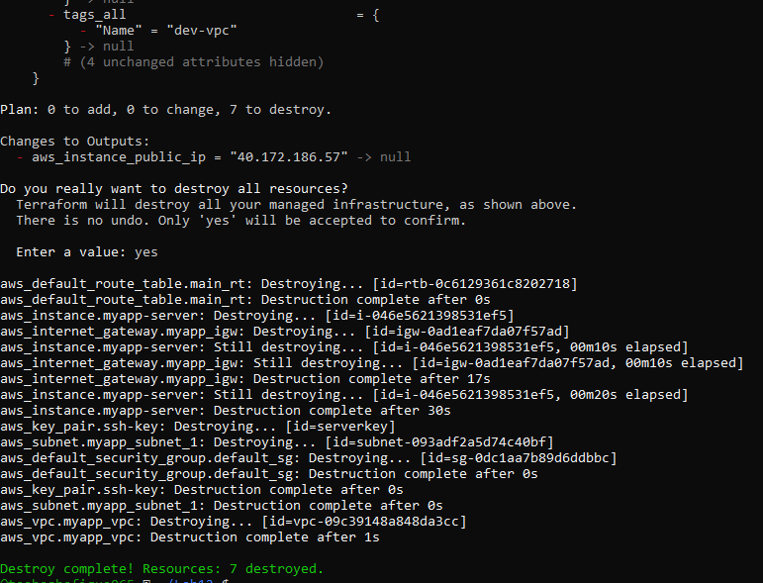
- task3_main_tf_restored.png
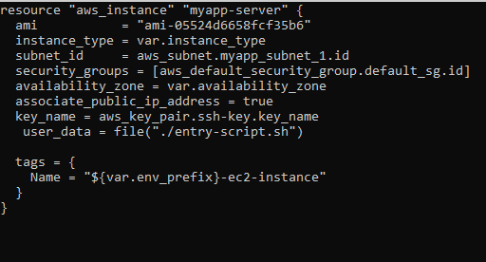

Task 4 — Subnet Module
Screenshots Required:
- task4_module_structure.png
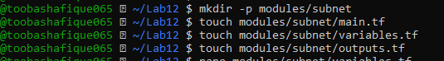
- task4_subnet_variables.png
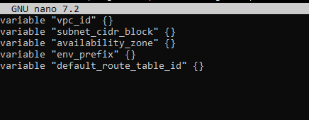
- task4_subnet_main.png
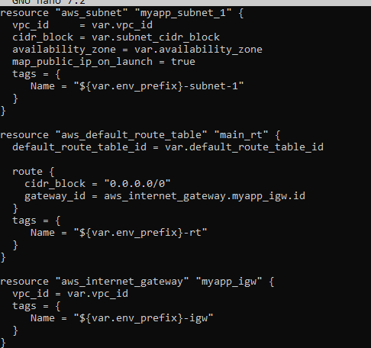
- task4_subnet_outputs.png
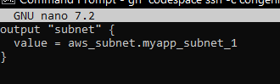
- task4_main_tf_with_module.png
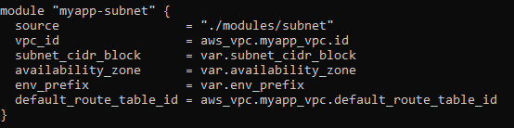
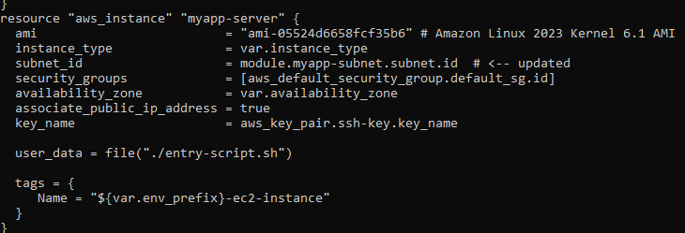
- task4_terraform_init.png
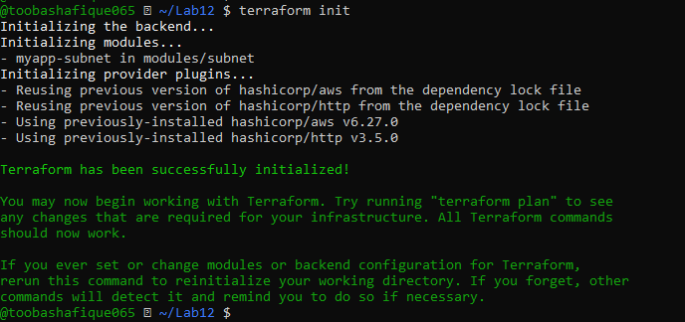
- task4_terraform_apply.png
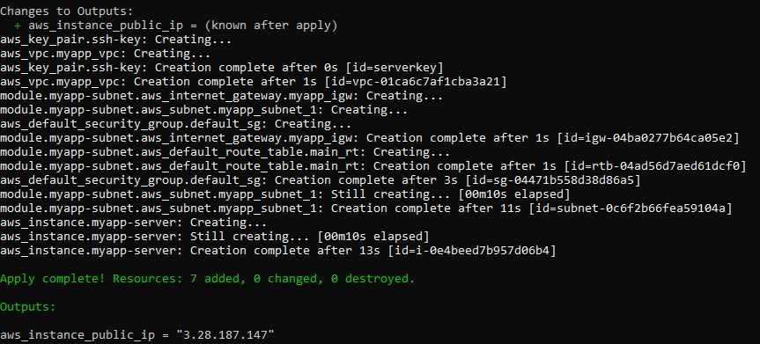
- task4_terraform_output.png
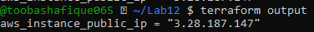
- task4_nginx_browser.png
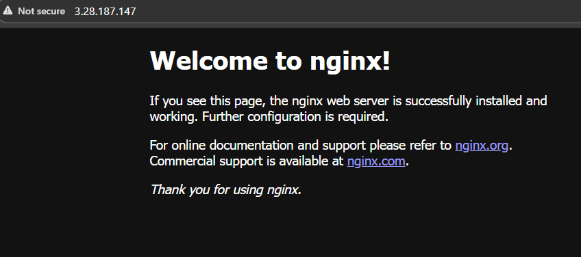

Task 5 — Webserver Module
Screenshots Required:
- task5_webserver_module_structure.png
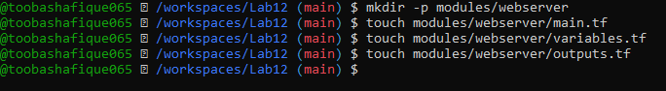
- task5_webserver_variables.png
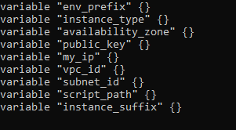
- task5_webserver_main.png
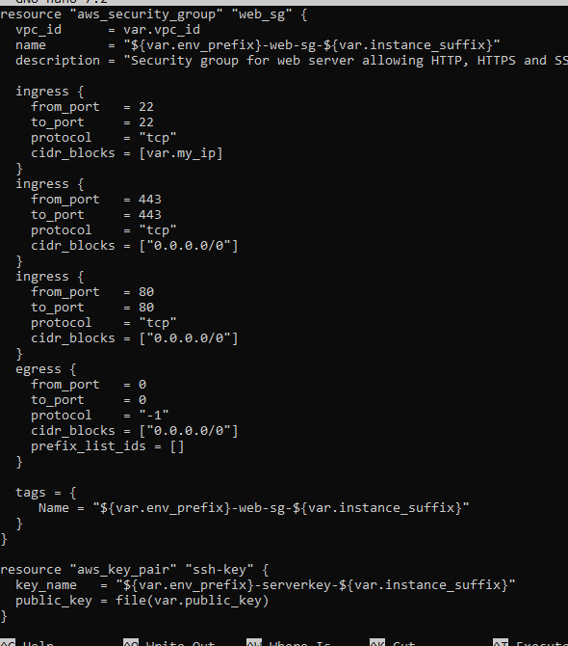
- task5_webserver_outputs.png
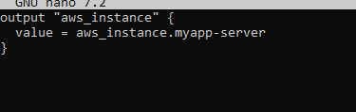
- task5_main_tf_webserver_module.png
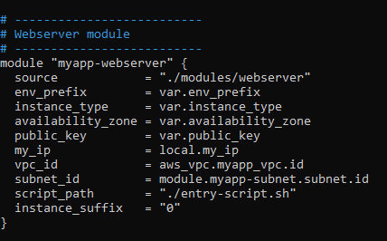
- task5_outputs_updated.png
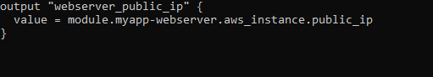
- task5_terraform_init.png
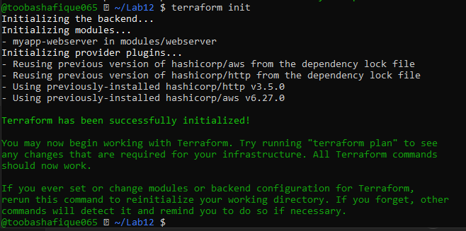
- task5_terraform_apply.png
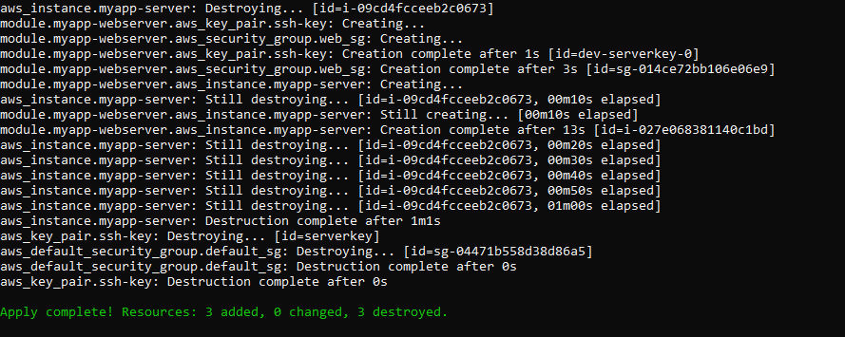
- task5_terraform_output.png
- task5_nginx_browser.png
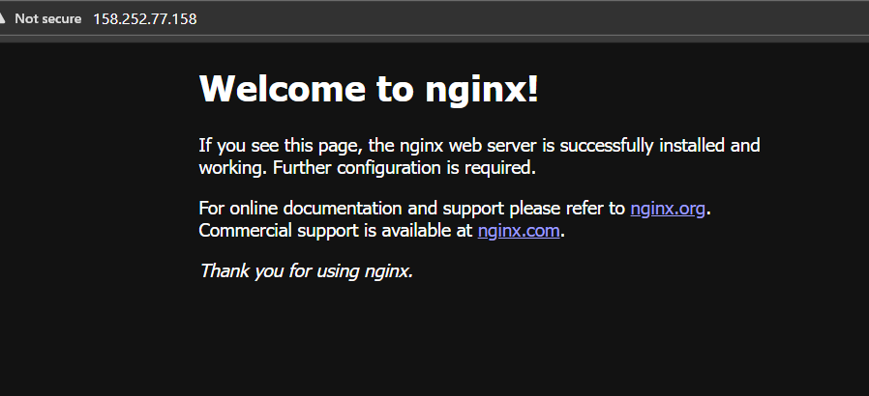
- task5_terraform_destroy.png
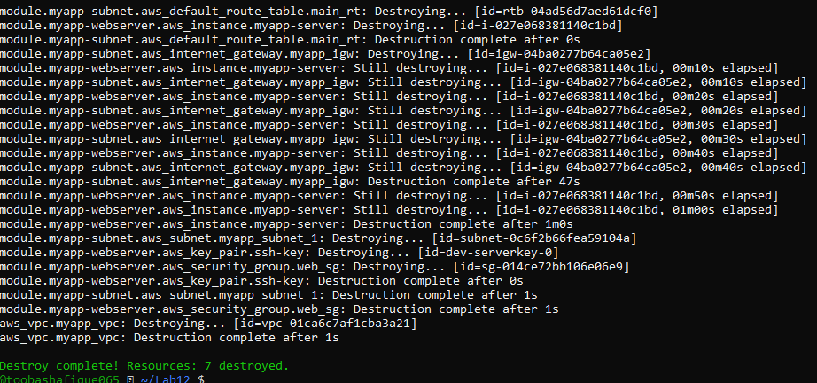

Task 6 — HTTPS with Self-signed Certificates
Screenshots Required:
- task6_entry_script_https.png
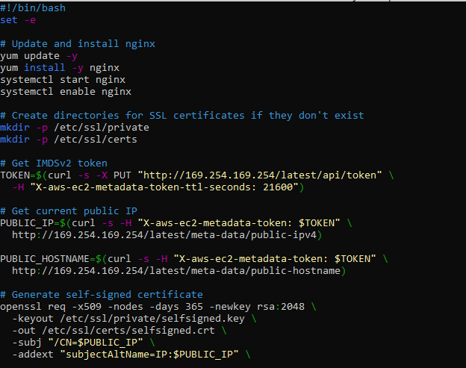
- task6_terraform_apply.png
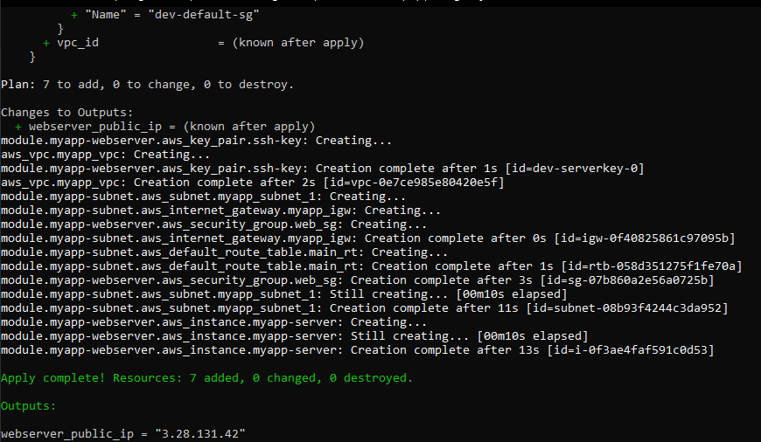
- task6_terraform_output.png
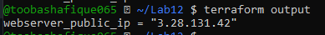
- task6_browser_security_warning.png
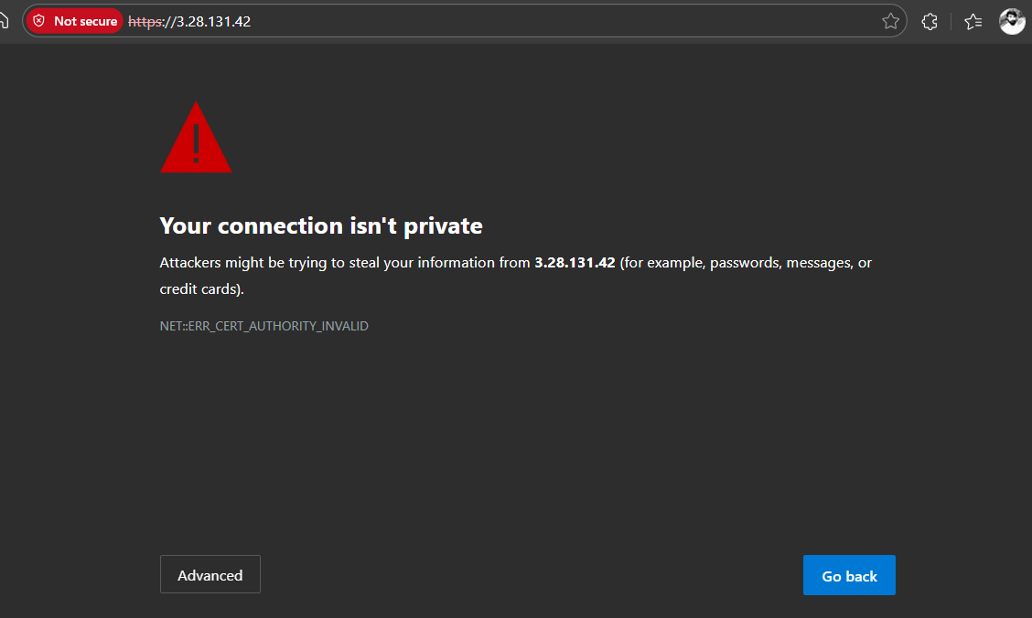
- task6_nginx_https_browser.png
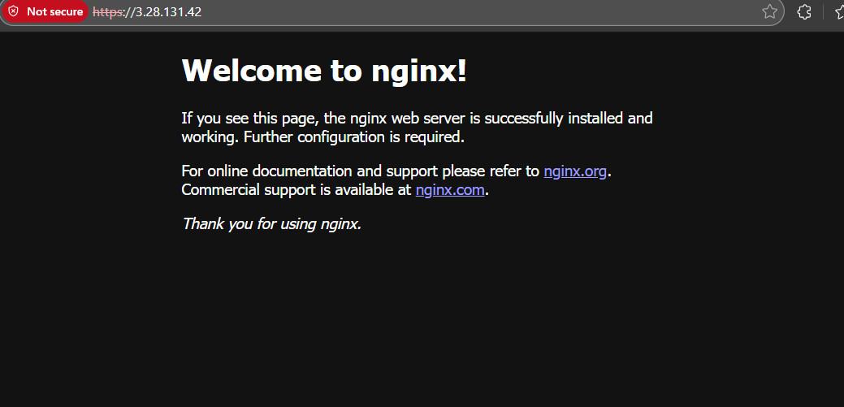
- task6_http_redirect.png
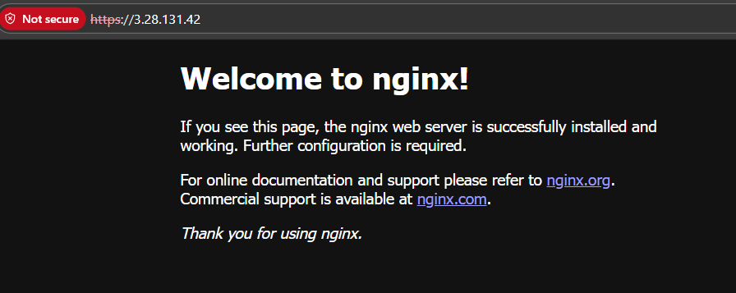

Task 7 — Nginx Reverse Proxy
Screenshots Required:
- task7_apache_script.png
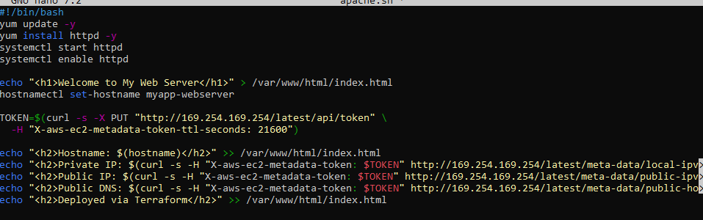
- task7_main_tf_web1.png
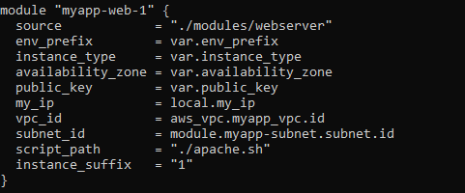
- task7_outputs_web1.png
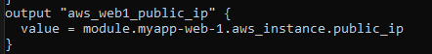
- task7_terraform_apply.png
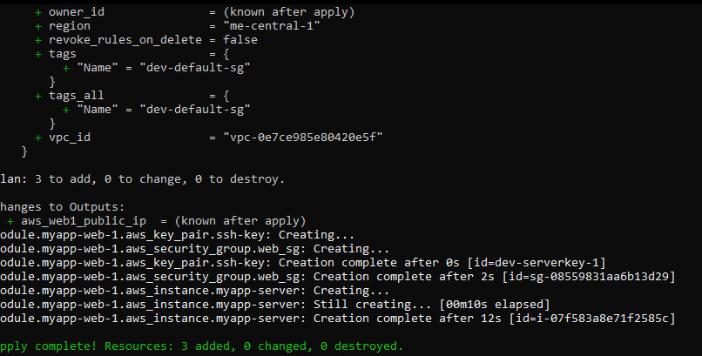
- task7_terraform_output.png 3.28.131.42
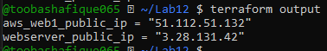
- task7_ssh_webserver.png
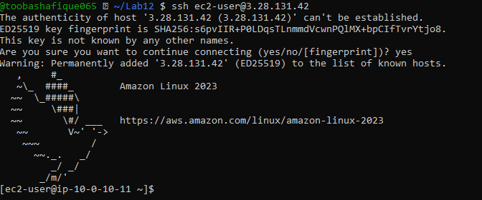
- task7_nginx_conf_reverse_proxy.png
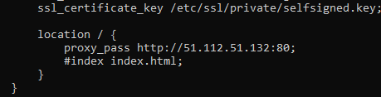
- task7_nginx_restart.png
- task7_error_log.png
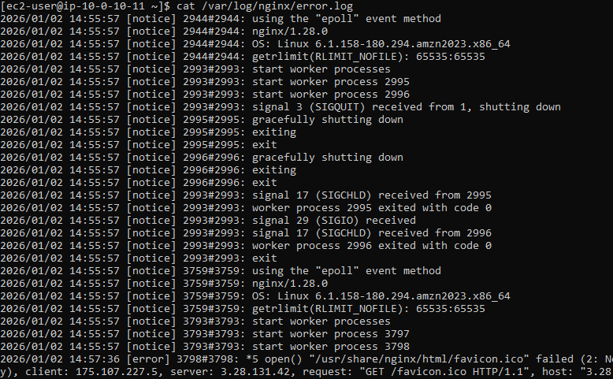
- task7_access_log.png
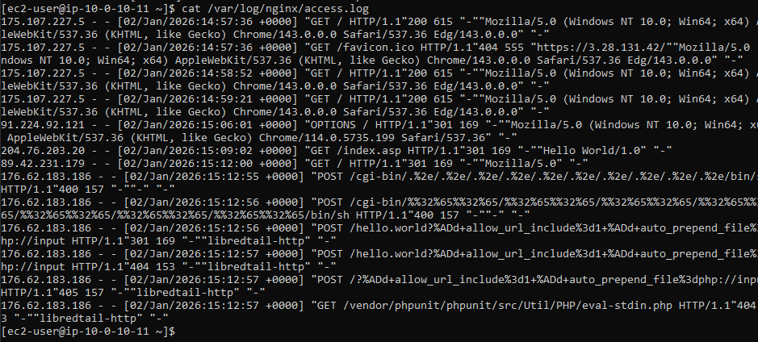
- task7_mime_types.png
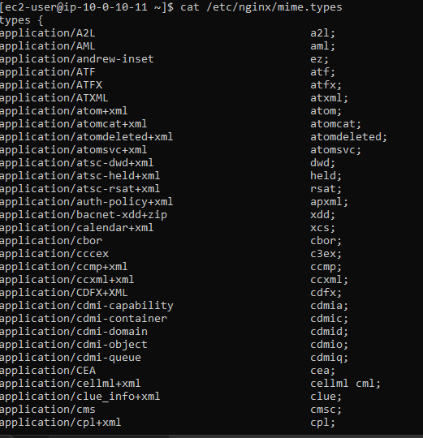
- task7_ssl_cert.png
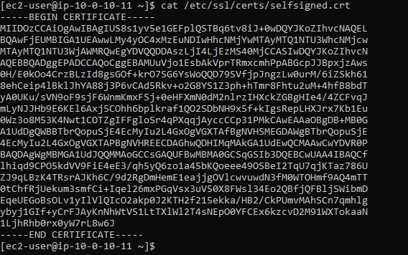
- task7_ssl_key.png
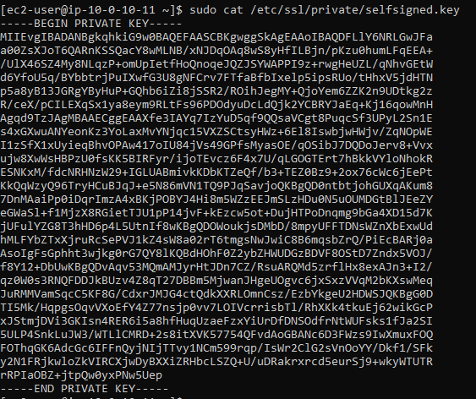
- task7_reverse_proxy_browser.png
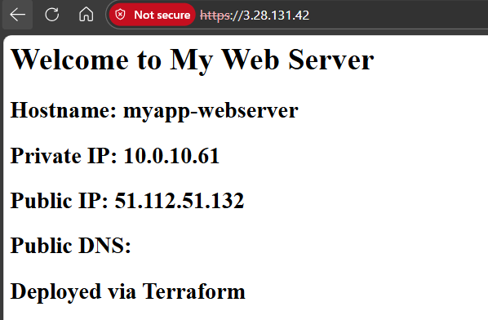

Task 8 — Nginx Load Balancer
Screenshots Required:
- task8_main_tf_web2.png
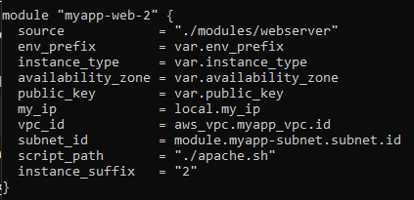
- task8_outputs_web2.png
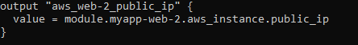
- task8_terraform_apply.png
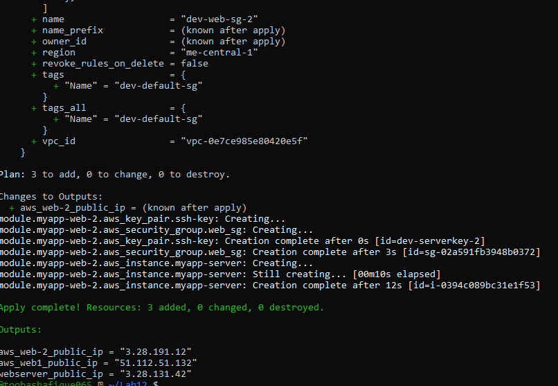
- task8_terraform_output.png
aws_web-2_public_ip = "3.28.191.12"
aws_web1_public_ip = "51.112.51.132"
webserver_public_ip = "3.28.131.42"
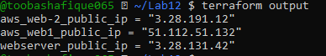
- task8_nginx_conf_load_balancer.png
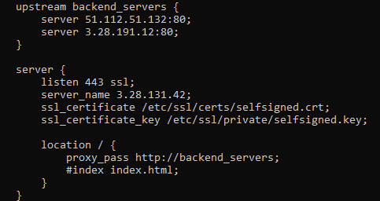
- task8_nginx_restart.png
- task8_load_balancer_web1.png
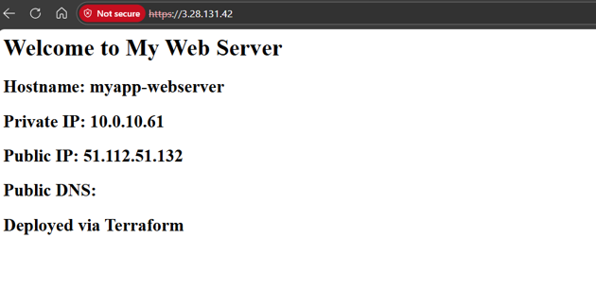
- task8_load_balancer_web2.png
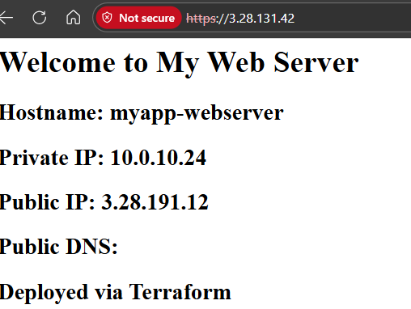

Task 9 — High Availability (Backup Servers)
Screenshots Required:
- task9_nginx_conf_ha_web1_primary.png
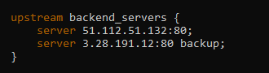
- task9_ha_web1_only.png
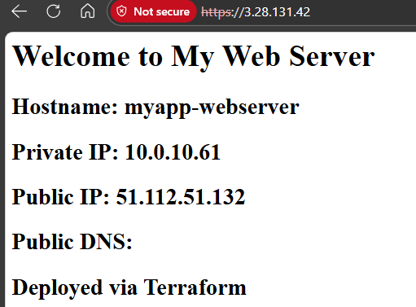
- task9_nginx_conf_ha_web2_primary.png
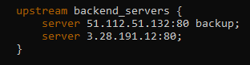
- task9_ha_web2_only.png
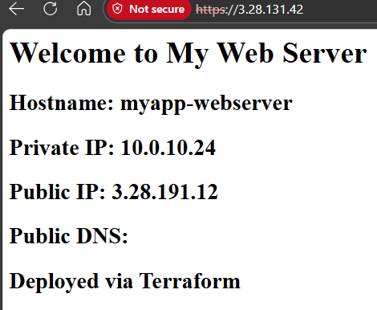

Task 10 — Nginx Caching
Screenshots Required:
- task10_nginx_conf_cache.png
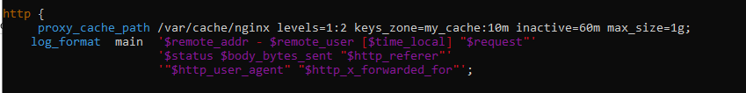
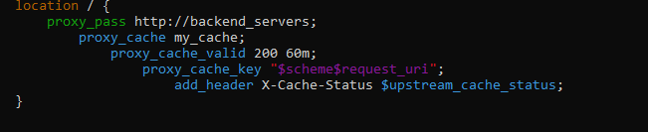
- task10_nginx_restart.png
- task10_cache_miss.png
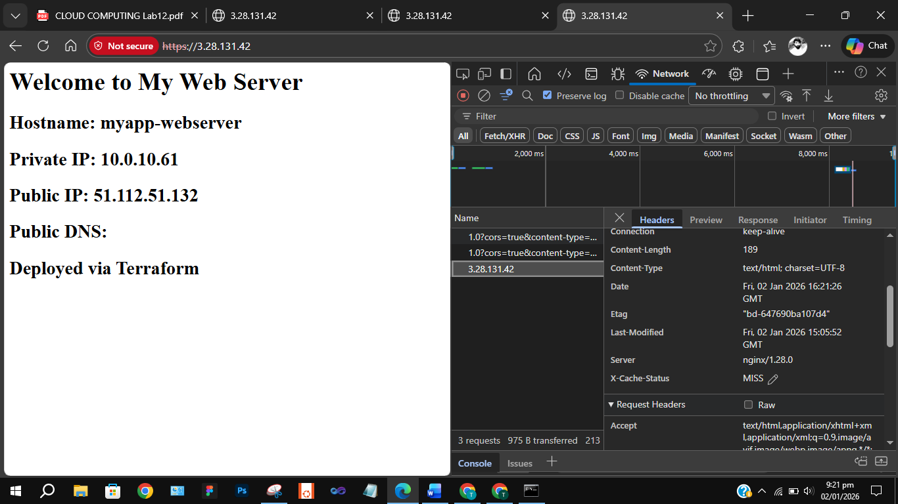
- task10_cache_hit.png
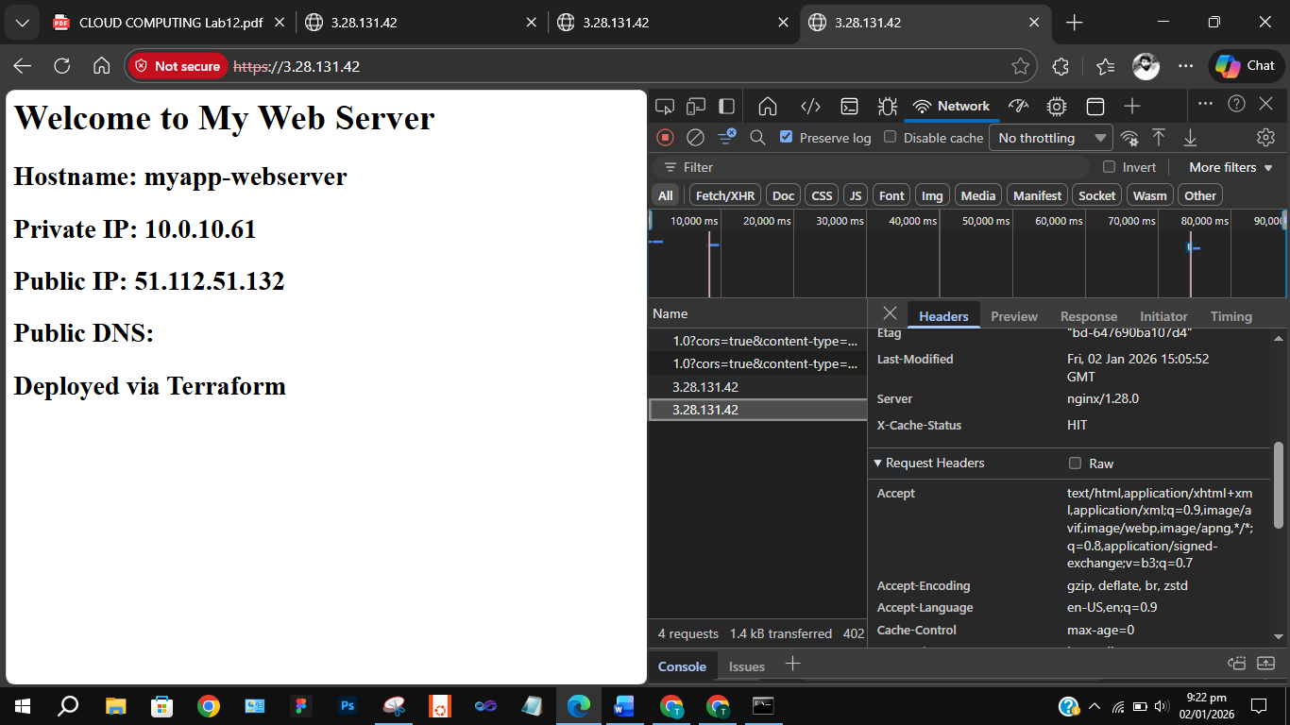
- task10_cache_directory.png
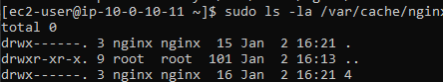

Cleanup
Screenshots Required:
- cleanup_destroy_prompt.png
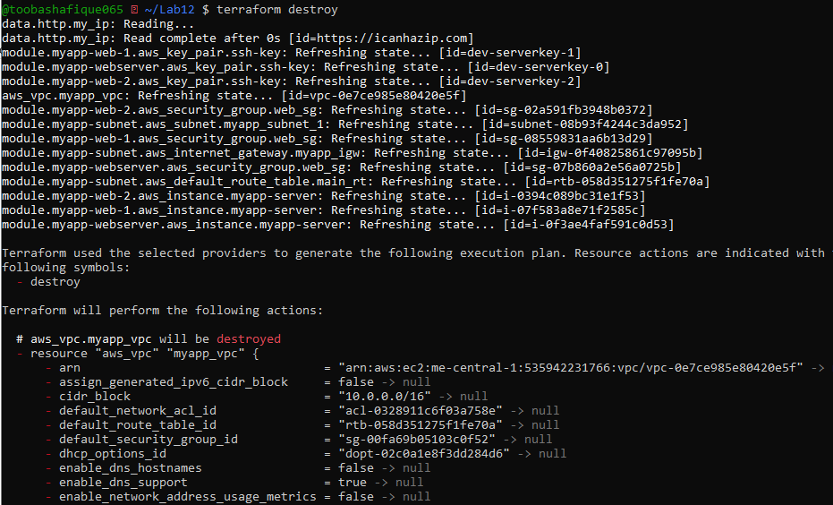
- cleanup_destroy_complete.png
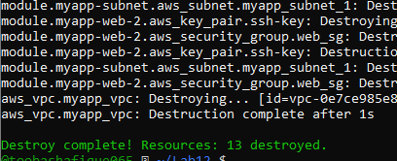
- cleanup_state_empty.png
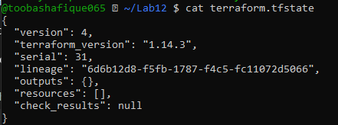
- cleanup_final_files.png
